Data Manipulation Frameworks with Pandas

1. Core Architecture of Pandas Series and DataFrames
Pandas is an open-source Python library designed for high-performance data manipulation, cleaning, and structured analysis. In clinical trials, pharmacokinetic (PK) modeling, and pharmacovigilance (PV) monitoring, data arrives in highly structured formats—ranging from continuous concentration-time logs to categorical adverse event reports.
Pandas provides two foundational data structures for handling these tabular data models: Series and DataFrames.
The Pandas Series
A Series is a one-dimensional labeled array capable of holding any data type (integers, floating-point numbers, strings, or Python objects). It consists of two primary components:
- 1. Values: An underlying 1D array holding the actual data values.
- 2. Index: A sequence of data labels attached to each value, serving as structural row references.
In clinical informatics, a single column—such as a sequence of plasma concentrations measured at specified time intervals—is naturally represented as a Series.
import pandas as pd

# Creating a basic 1D Series representing drug concentration values
concentration_series = pd.Series([0.0, 2620.051, 2635.714, 2572.759])
print("Basic Series:")
print(concentration_series)

Series Indexing Strategies
Pandas supports two primary indexing mechanics for accessing data within a Series or DataFrame:
- Position-based Indexing (.iloc): Accesses elements using zero-based integer positions, similar to standard Python lists.
- Label-based Indexing (.loc): Accesses elements using custom-assigned index labels or timestamps.
# Defining a Series with explicit, custom timepoint labels
pk_timepoint_series = pd.Series(
[0.0, 2620.051, 2635.714, 2572.759],
index=["0h", "0.25h", "0.5h", "1h"]
)

# Position-based access (.iloc)
val_pos = pk_timepoint_series.iloc[1]

# Label-based access (.loc)
val_lbl = pk_timepoint_series.loc["0.25h"]

print(f"Value at position 1 (.iloc): {val_pos}")
print(f"Value at label '0.25h' (.loc): {val_lbl}")

The Pandas DataFrame
A DataFrame is a two-dimensional, size-mutable tabular data structure with labeled axes (rows and columns). Conceptually, a DataFrame is an aligned collection of Series sharing a common index.
# Constructing a DataFrame from a dictionary of lists
pk_summary_df = pd.DataFrame({
'Patient_ID': ['PAT-PK-001', 'PAT-PK-002', 'PAT-PK-003'],
'Age': [39, 24, 63],
'Weight_kg': [60.9, 80.7, 79.6]
})

print("Constructed DataFrame:")
print(pk_summary_df)

2. Ingestion of Pharmacokinetic and Pharmacovigilance Data
Clinical data pipelines ingest raw measurements from varied external storage formats. The primary file types encountered in clinical data workflows are Comma-Separated Values (.csv) and Microsoft Excel Workbooks (.xlsx).
Ingesting Structured Pharmacokinetic (PK) CSV Files
In PK tracking files, each row corresponds to a single blood sampling event, capturing time-stamped drug concentrations alongside patient demographic markers and calculated physiological metrics like Clearance (CL) and Volume of Distribution (Vd).
# Reading the PK tracking dataset from a CSV file
pk_df = pd.read_csv("pk_tracking_data.csv")

# Selecting specific columns for analysis
demographics = pk_df[["Patient_ID", "Age", "Gender", "Weight_kg"]]

# Displaying the first row using loc
first_record = pk_df.loc[0]

print("First Record Ingested:")
print(first_record)

Handling Adverse Drug Reaction (ADR) Excel Worksheets
Pharmacovigilance datasets often log safety events across multi-tabbed Excel spreadsheets. You can target specific worksheets during ingestion using pd.read_excel() and the sheet_name parameter:
# Ingesting a specific sheet from an Excel workbook
try:
adr_df = pd.read_excel("adr_pv_logs.xlsx", sheet_name="Serious_ADRs")
print("Successfully ingested ADR Excel Sheet.")
except FileNotFoundError:
print("Spreadsheet file path not resolved; check local environment.")

3. Preliminary Inspection and Filtering of Raw Data Sheets
Before performing statistical modeling, raw data must be thoroughly inspected. Pandas provides structural inspection methods—head(), tail(), info(), and describe()—to evaluate schema integrity, missingness, and scalar distributions.
# Load PK tracking data
pk_data = pd.read_csv("pk_tracking_data.csv")

# 1. View first 5 rows
print("--- HEAD (First 5 Rows) ---")
print(pk_data.head())

# 2. View last 5 rows
print("\n--- TAIL (Last 5 Rows) ---")
print(pk_data.tail())

# 3. Structural overview (data types and non-null counts)
print("\n--- INFO ---")
pk_data.info()

# 4. Descriptive statistical summary
print("\n--- DESCRIBE ---")
print(pk_data.describe())

Statistical Metrics Provided by .describe()
When called on numerical columns, .describe() returns key descriptive statistics:
- count: Number of non-null entries.
- mean: Arithmetic mean of the column.
- std: Standard deviation measuring statistical dispersion.
- min / max: Minimum and maximum observed values.
- 25%, 50%, 75%: 25th percentile, median (50th percentile), and 75th percentile values.
Conditional Filtering
Boolean masking enables targeted queries based on physiological threshold constraints:
# Filter for therapeutic concentrations exceeding 5000 ng/mL
high_conc_df = pk_data[pk_data["Concentration_ng_mL"] > 5000]
print("High Concentration Events ( > 5000 ng/mL ):")
print(high_conc_df[["Patient_ID", "Drug_Name", "Timepoint_hrs", "Concentration_ng_mL"]].head())

# Multi-condition filtering: Patients > 50 years old receiving LYK-440
elderly_lyk = pk_data[(pk_data["Age"] > 50) & (pk_data["Drug_Name"] == "LYK-440")]
print("\nElderly Cohort receiving LYK-440:")
print(elderly_lyk[["Patient_ID", "Age", "Drug_Name"]].drop_duplicates())

4. Cleaning, Missing Value Management, and Transformation
Data ingested from raw clinical operational software often contains missing values or superfluous structural elements.
Detecting and Imputing Missing Data
# Load academic demonstration dataset
student_df = pd.read_csv("student.csv")

# Detect missing entries per column
print("Missing values count per column:")
print(student_df.isnull().sum())

# Impute missing values with a default value (e.g., 0)
imputed_df = student_df.fillna(0)
print("\nDataFrame after fillna(0):")
print(imputed_df)

Modifying Structure: Column Creation and Deletion
Columns can be added dynamically or removed using .drop():
# Add a categorical column to the dataset
student_df["Grade"] = ["B", "B", "A", "C", "A", "B", "A", "C", "B", "C"]
print("Updated DataFrame with Grade column:")
print(student_df.head(3))

# Delete a column along axis=1
student_df.drop("Grade", axis=1, inplace=True)
print("\nDataFrame after dropping 'Grade' column:")
print(student_df.head(3))

# Exporting cleaned data to CSV without writing row indices
student_df.to_csv("processed_students.csv", index=False)

5. Structural Aggregation and Grouping Mechanics
The groupby() method splits a DataFrame into logical subgroups, applies an analytical function, and combines the results into a summarized structure.
# Grouping by Department and calculating mean Marks
df_student = pd.read_csv("student.csv")
avg_marks = df_student.groupby("Department")["Marks"].mean()
print("Mean Marks by Department:")
print(avg_marks)

# Comprehensive aggregation using .agg()
dept_summary = df_student.groupby('Department').agg(
Total_Students=('Student_ID', 'count'),
Avg_Marks=('Marks', 'mean'),
Max_Marks=('Marks', 'max'),
Min_Marks=('Marks', 'min')
)
print("\nDepartment Summary Table:")
print(dept_summary)

6. End-to-End Case Studies and Visualizations
This section presents two complete case studies using real PK trial data (pk_tracking_data.csv).
Case Study A: Comparative Drug Clearance Analysis
In clinical pharmacology, clearance (CL) measures the volume of plasma cleared of drug per unit time (L/h). Higher clearance indicates faster elimination.
import pandas as pd
import matplotlib.pyplot as plt

# 1. Load dataset
pk_df = pd.read_csv("pk_tracking_data.csv")

# 2. Group by Drug_Name and calculate average clearance
avg_cl = pk_df.groupby("Drug_Name")["Calculated_CL_L_h"].mean()

# 3. Print quantitative results
print("Average Clearance Values:")
print(avg_cl)

# 4. Plot comparative bar chart
plt.figure(figsize=(6, 4))
avg_cl.plot(kind="bar", color=['#1f77b4', '#ff7f0e'], edgecolor='black')
plt.title("Average Clearance (CL) by Drug")
plt.xlabel("Drug Name")
plt.ylabel("Clearance (L/h)")
plt.grid(axis='y', linestyle='--', alpha=0.7)
plt.tight_layout()
plt.show()

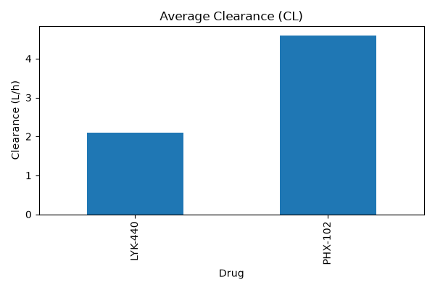

Analytical Findings: Drug Clearance
• PHX-102: Average clearance ≈ 4.6 L/h
• LYK-440: Average clearance ≈ 2.1 L/h
Pharmacokinetic Significance: PHX-102 is cleared approximately 2.2 times faster than LYK-440. This rapid elimination means PHX-102 requires more frequent dosing to stay within the therapeutic window, whereas LYK-440 remains in circulation longer.

Case Study B: Longitudinal Concentration-Time Profiles
Unstacking aggregated time-series data allows us to plot mean concentration profiles over time.
import pandas as pd
import matplotlib.pyplot as plt

# 1. Load dataset
pk_df = pd.read_csv("pk_tracking_data.csv")

# 2. Pivot data into a 2D grid (Drugs x Timepoints)
mean_conc=pk_df.groupby(["Drug_Name","Timepoint_hrs"])["Concentration_ng_mL"].mean().unstack()

# 3. Plot concentration-time profiles
plt.figure(figsize=(8, 5))
mean_conc.T.plot(figsize=(8, 5), marker='o')
plt.title("Average Concentration-Time Profile")
plt.xlabel("Time (hours)")
plt.ylabel("Concentration (ng/mL)")
plt.grid(True)
plt.tight_layout()
plt.show()

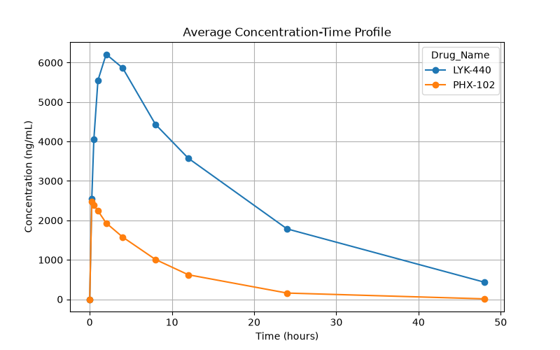

Analytical Findings: Concentration Profiles
1. Peak Concentration (Cmax):
- LYK-440 reaches a much higher peak concentration (≈ 6,200 ng/mL).
- PHX-102 reaches a lower peak concentration (≈ 2,500 ng/mL).
2. Time to Peak (Tmax):
- PHX-102 peaks rapidly at 0.25 - 0.5 hours post-administration, consistent with its IV infusion route.
- LYK-440 peaks later at ≈ 2 hours, reflecting oral absorption kinetics.

Case Study C: Patient Age vs. Volume of Distribution (Vd)
import pandas as pd
import matplotlib.pyplot as plt

# 1. Load dataset and isolate single patient records
pk_df = pd.read_csv("pk_tracking_data.csv")
patient_data = pk_df.drop_duplicates("Patient_ID")

# 2. Generate scatter plot
plt.figure(figsize=(6, 5))
plt.scatter(patient_data["Age"], patient_data["Calculated_Vd_L"], color='purple', alpha=0.7)
plt.xlabel("Age (years)")
plt.ylabel("Volume of Distribution (L)")
plt.title("Age vs Volume of Distribution (Vd)")
plt.grid(True)
plt.tight_layout()
plt.show()

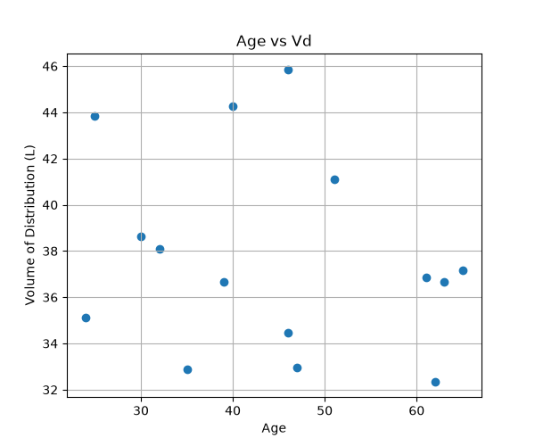

Function / Method | Primary Purpose | Structural Output
pd.Series(data, index) | Constructs a 1D labeled array | Series
pd.DataFrame(data) | Constructs a 2D tabular structure | DataFrame
pd.read_csv(filepath) | Reads a comma-separated values file into a DataFrame | DataFrame
df.head(n) / df.tail(n) | Inspects the first or last n rows | DataFrame
df.info() | Prints data types and non-null entry counts | Console Text Output
df.describe() | Computes descriptive statistics for numerical columns | DataFrame
df.loc[] / df.iloc[] | Selects rows/columns by label (loc) or position (iloc) | Series or DataFrame
df.isnull().sum() | Counts missing values per column | Series
df.fillna(value) | Fills missing (NaN) values with a designated replacement | DataFrame
df.drop() | Removes specified rows or columns | DataFrame
df.groupby() | Splits data into logical subsets for aggregation | DataFrameGroupBy
df.to_csv(filepath) | Exports a DataFrame to a CSV file | File Output

Analytical Findings: Age vs Vd
• Absence of a Strong Linear Trend: Data points are broadly scattered across ages 25 to 65 without showing a strong upward or downward correlation.
• Distribution Range: Across the observed population, Vd values range between 32 L and 46 L, indicating that age alone does not account for variations in distribution volume within this study group.
7. Summary Reference Manual

Summary

